Economics
Chapter 11, Section 3
POVERTY & INCOME DISTRIBUTION
Poverty Threshold

Poverty Rate

Distribution of Income

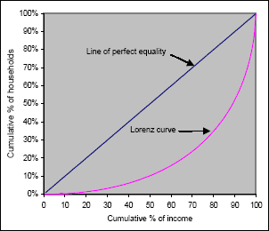
Lorenz Curve

Gini Index

Are the rich getting richer and the poor getting poorer??
Changes in Households | Changes in the Labor Market
Changes in Technology | The Growth of a Global Economy

