ECONOMICS
Chapter 11, Section 2
INFLATION

You may have heard relatives talk about the good old days when a dollar would buy something.
- What happened to that dollar?
- Why won’t it buy as much as it did last month or last year?
INFLATION HAPPENED.
◊
When quantity demanded exceeds quantity supplied, prices go up and the purchasing power of a dollar goes down.

Simply put, inflation is a rise in prices relative to money available. In other words, you can get less for your money than you used to be able to get.

You buy a candy bar for 50 cents. A year later, you go to buy the same candy bar and it's 55 cents. You still have only 50 cents, but the price of the candy bar has gone up. We can say that inflation is at work. The price of that bar has been inflated.

People usually refer to inflation when they talk about the prices of large-ticket items, like cars and houses and stocks. But inflation also affects things like groceries and house supplies. It can also affect things like house payments and rent.

When inflation rises but people's paychecks don't, this means that people have spend more of the money to buy the same things that they used to be able to buy for less.

INFLATION

DEFLATION

AGGREGATE SUPPLY

AGGREGATE DEMAND

THE CAUSES OF INFLATION

DEMAND-PULL INFLATION
- When aggregate demand increases faster than the economy’s productive capacity, demand-pull inflation results.

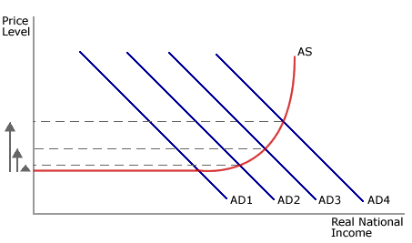
COST-PUSH INFLATION
- When producers raise prices to cover higher resource costs, cost-push inflation results.

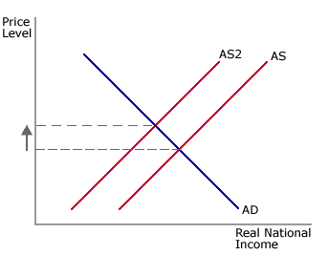
WAGE PRICE SPIRAL

SUPPLY SHOCK

